Spirituality in our Art Curriculum
At Highfield St Matthew’s, we use the Candle, Windows, Mirrors and Doors approach to support children in their spiritual and moral development.
“Spirituality is not something we can see; it is something we feel inside ourselves. It is about awe and wonder, asking questions, inspiration and being aware of something ‘bigger’ outside of ourselves.”
Spiritual Development – Candle, Windows, Mirrors and Doors
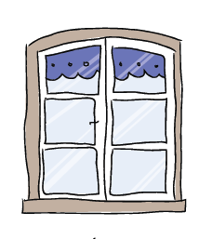 | The Window – Looking Out  Learning about encounters  The image of the window symbolises ‘looking out’ at the awe and wonder of the world. The window also helps us to question things which may worry us or take us by surprise.  The window prompts children to reflect upon what they see around them as they look out upon the world we live in. | - Children understand that all Art tells a story and recognise that every creation has embarked on a different journey, originating from culture, tradition, expression and emotion.  - Children appreciate that Art and Design shapes our history and contributes to the representation and creativity of our nation.  - Children admire the ‘awe and wonder’ of Art in our environment – both natural and man-made - and are enchanted by the beauty of God’s amazing creation.  - Art enables children to express their feelings and emotions through every artistic forms, in response to the delight and disasters of the world.
 | The Mirror – Looking In  Learning from reflections  The mirror symbolises reflecting upon your own actions, thoughts and beliefs to ‘look inside’ and to ask important questions, learning from our own and other’s responses. | - Art allows children to be present in the moment and to appreciate the natural wonders of the world around us, which in turn inspire us e.g. sunset, ocean, landscapes.  - Art enables children to be reflective about their own creativity, exploring and extending their imagination as they connect spiritually with the work of influential artists.  - Art is thought provoking and captivates curiosity when showing respect for the imagination of others and themselves.
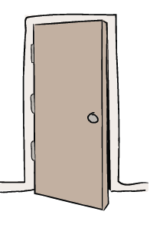 | The Door – Actions for Change  Putting thoughts and ideas into action.  The symbol of the door allows children to have opportunities to respond, to do something, to go through the door and take action.  The door aims to develop and nurture children to have the confidence to truly believe that they can make a difference in the world. | - Art allows children to express themselves in an innovative way in response to different emotions, beliefs and movements.  - Art promotes the discussion and interpretation of powerful messages evoking an emotional response which lead to an action for change.  - The showcasing of Art binds communities together to respect one another’s interpretations and delight in the collaboration of pioneering projects.

culture, pl environments that they are learning ab

