Spirituality in our English Curriculum
At Highfield St Matthew’s, we use the Candle, Windows, Mirrors and Doors approach to support children in their spiritual and moral development. We have looked at our bespoke ‘SHINE Curriculum’ to identify subject specific spirituality opportunities for each curriculum area.
“Spirituality is not something we can see; it is something we feel inside ourselves. It is about awe and wonder, asking questions, inspiration and being aware of something ‘bigger’ outside of ourselves.”

Spiritual Development – Candle, Windows, Mirrors and Doors
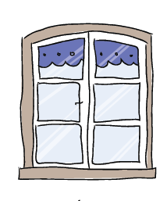 | The Window – Looking Out  Learning about encounters  The image of the window symbolises ‘looking out’ at the awe and wonder of the world. The window also helps us to question things which may worry us or take us by surprise.  The window prompts children to reflect upon what they see around them as they look out upon the world we live in. | - Reading and listening to all types of stories from a range of cultures around the world, evokes an emotional response by exploring a wide variety of text types and genres.  - Stories, writing and poetry captivate the imagination of children to enable them to connect with characters and settings which immerses them in the text.  - The power of written, spoken and performed words promote strong messages which children take delight in and inspires them to be creative.
 | The Mirror – Looking In  Learning from reflections  The mirror symbolises reflecting upon your own actions, thoughts and beliefs to ‘look inside’ and to ask important questions, learning from our own and other’s responses. | - Through stories and creative writing, children develop empathy by thinking beyond themselves as they connect with cultures, situations and characters.  - By looking at different forms of writing, children learn to be present in the moment, reflect and appreciate of their own creative writing skills and the writing talents of others.  - By analysing stories from other cultures, children learn to question their own thoughts, beliefs and values.
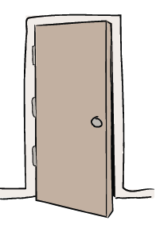 | The Door – Actions for Change  Putting thoughts and ideas into action.  The symbol of the door allows children to have opportunities to respond, to do something, to go through the door and take action.  The door aims to develop and nurture children to have the confidence to truly believe that they can make a difference in the world. | - Children are given opportunities to express themselves spiritually and share their passions through Performance Poetry and writing which gives them the confidence to make a change.  - English gives opportunities for children to respond to issues and action them within many different forms such as persuasion, debate and poetry.

