Spirituality in our Geography Curriculum
At Highfield St Matthew’s, we use the Candle, Windows, Mirrors and Doors approach to support children in their spiritual and moral development.
“Spirituality is not something we can see; it is something we feel inside ourselves. It is about awe and wonder, asking questions, inspiration and being aware of something ‘bigger’ outside of ourselves.”
Spiritual Development – Candle, Windows, Mirrors and Doors
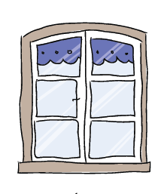 | The Window – Looking Out  Learning about encounters  The image of the window symbolises ‘looking out’ at the awe and wonder of the world. The window also helps us to question things which may worry us or take us by surprise.  The window prompts children to reflect upon what they see around them as they look out upon the world we live in. | - Children appreciate what our wonderful world has to offer (the human and physical features) and it inspires them to go and explore the beauty of God’s amazing creation.  - Children experience a sense of wonder and fascination when they encounter, ‘What is it like to live in different locations around the world?’  - Through fieldwork opportunities, children experience moments of stillness to appreciate what they have in their local environment.  - Children question how they can make a difference to our local environment and to issues affecting our earth.
 | The Mirror – Looking In  Learning from reflections  The mirror symbolises reflecting upon your own actions, thoughts and beliefs to ‘look inside’ and to ask important questions, learning from our own and other’s responses. | - Through enquiry, children reflect and respond to natural disasters and emphasise with people and communities around the world.  - In recognition of our diverse world, children show respect and understand how other communities are different from our own.  - Children are motivated to investigate the physical world and are enabled to recognise the importance of sustainable development for the future.  - Children reflect upon the advantages and disadvantages of living in different locations.  - When considering our school Christian Values, children look inward and ask important questions, triggering an emotional response about the impacts on their surroundings.
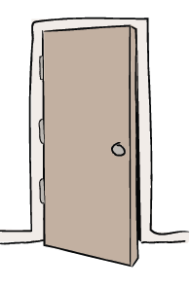 | The Door – Actions for Change  Putting thoughts and ideas into action.  The symbol of the door allows children to have opportunities to respond, to do something, to go through the door and take action.  The door aims to develop and nurture children to have the confidence to truly believe that they can make a difference in the world. | - Children can make sense of world around them and feel empowered to look after God’s creation.  - Children act as global supporters, sharing messages about issues facing our world including Eco Warriors and School Council.  - Children respond to the affects of natural disasters by taking part in acts of advocacy.  - Children respond to local issues and act as advocates for change in projects, which they are passionate about.

culture, pl environments that they are learning ab

