Spirituality in our Maths Curriculum
At Highfield St Matthew’s, we use the Candle, Windows, Mirrors and Doors approach to support children in their spiritual and moral development.
“Spirituality is not something we can see; it is something we feel inside ourselves. It is about awe and wonder, asking questions, inspiration and being aware of something ‘bigger’ outside of ourselves.”
Spiritual Development – Candle, Windows, Mirrors and Doors
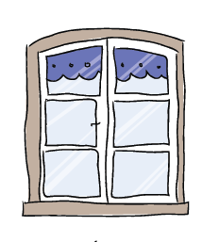 | The Window – Looking Out  Learning about encounters  The image of the window symbolises ‘looking out’ at the awe and wonder of the world. The window also helps us to question things which may worry us or take us by surprise.  The window prompts children to reflect upon what they see around them as they look out upon the world we live in. | - Our Maths curriculum allows children to marvel at the links with other areas of the curriculum and how they connect to enhance one another.  - Opportunities to appreciate the beauty of Maths through awe and wonder all around them - including pattern, shape, relationships etc.  - Using nature to enhance the Maths curriculum through exploration and provision, children experience Maths in the natural environment of God’s world.  - Extensive opportunities for problem solving are provided through the mastery approach which give opportunities to explore and investigate.
 | The Mirror – Looking In  Learning from reflections  The mirror symbolises reflecting upon your own actions, thoughts and beliefs to ‘look inside’ and to ask important questions, learning from our own and other’s responses. | - Our Maths curriculum allows children to self-reflect upon their achievements, building resilience when they are faced with Mathematical challenges and pride when they find solutions.  - In maths lessons, pupils are always encouraged to delve deeper into their understanding of Maths and how it relates to the world around them and how they can use and apply the skills they learn in the ‘real world’.  - The curriculum offers opportunities to explore aspects of God’s creation such curiosity of time, is there such a thing as the present moment and exploring the fascination of infinite endless opportunities.
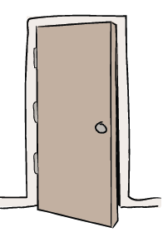 | The Door – Actions for Change  Putting thoughts and ideas into action.  The symbol of the door allows children to have opportunities to respond, to do something, to go through the door and take action.  The door aims to develop and nurture children to have the confidence to truly believe that they can make a difference in the world. | - Children make connections between Mathematical skills and applying them to real life contexts and situations. Maths can also be used to make sense of the world around them.  - Children respond to problem solving with confidence and follow a systematic approach when making predictions and exploring all possibilities.

