Spirituality in our Music Curriculum
At Highfield St Matthew’s, we use the Candle, Windows, Mirrors and Doors approach to support children in their spiritual and moral development.
“Spirituality is not something we can see; it is something we feel inside ourselves. It is about awe and wonder, asking questions, inspiration and being aware of something ‘bigger’ outside of ourselves.”
Spiritual Development – Candle, Windows, Mirrors and Doors
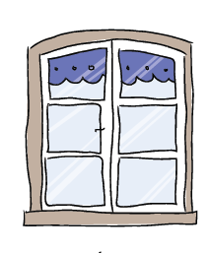 | The Window – Looking Out  Learning about encounters  The image of the window symbolises ‘looking out’ at the awe and wonder of the world. The window also helps us to question things which may worry us or take us by surprise.  The window prompts children to reflect upon what they see around them as they look out upon the world we live in. | - Music is designed to evoke curiosity resulting in discussions about a wide range of musicians, songs and life experiences and how these might be reflected in their own compositions.  - Children explore a wide range of music from all different cultures and celebrate differences, appreciating how music can bring people together around the world.  - Children delight in song through daily acts of worship and music/song allows children to connect with others and express their individual emotions.  - Lyrics are thought-provoking and allow children to be mindful about the meaning behind the words, understand the messages that are conveyed and stories that are told through music.
 | The Mirror – Looking In  Learning from reflections  The mirror symbolises reflecting upon your own actions, thoughts and beliefs to ‘look inside’ and to ask important questions, learning from our own and other’s responses. | - Children are captivated by music which is thought provoking and reflect upon their own responses to music through emotions, thoughts and feelings.  - Music develops confidence in children and gives them a strong sense of pride in their achievements, allowing them to ‘let go’ and be present in the moment.  - Music is inclusive and allows all children to express themselves in their own unique way, taking delight in the joy that music brings to us all.
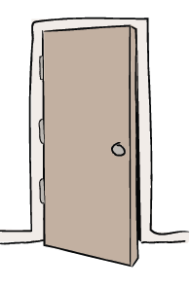 | The Door – Actions for Change  Putting thoughts and ideas into action.  The symbol of the door allows children to have opportunities to respond, to do something, to go through the door and take action.  The door aims to develop and nurture children to have the confidence to truly believe that they can make a difference in the world. | - Music binds communities together and gives children the opportunity to perform and enables them to continue their musical journey outside the classroom.  - Children use music as a form of expression and celebration by responding to seasonal themes and local and global events across the year.  - Children are inspired by musicians and are given opportunities to learn instruments and extend their talents by performing to the community.

culture, pl environments that they are learning ab

