At Highfield St Matthew’s, we use the Candle, Windows, Mirrors and Doors approach to support children in their spiritual and moral development.
“Spirituality is not something we can see; it is something we feel inside ourselves. It is about awe and wonder, asking questions, inspiration and being aware of something ‘bigger’ outside of ourselves.”
Spiritual Development – Candle, Windows, Mirrors and Doors
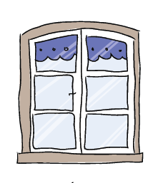 | The Window – Looking Out  Learning about encounters  The image of the window symbolises ‘looking out’ at the awe and wonder of the world. The window also helps us to question things which may worry us or take us by surprise.  The window prompts children to reflect upon what they see around them as they look out upon the world we live in. | - Throughout the Physical Education curriculum, children are inspired by influential athletes and sporting figures who have a positive impact on society.  - Children experience awe and wonder of physical expression and the emotive response associated with dance and sporting events.  - Children experience a sense of joy and have the opportunity to celebrate achievements when collaborating and working as part of a team towards a goal.  - Children are encouraged to be mindful and consider the impact of sport in the wider world and how this can connect countries, different cultures and communities together.
 | The Mirror – Looking In  Learning from reflections  The mirror symbolises reflecting upon your own actions, thoughts and beliefs to ‘look inside’ and to ask important questions, learning from our own and other’s responses. | - As part of each lesson, children review and reflect upon both their personal achievements and that of others’, to enhance potential whilst supporting each other and promoting sportsmanship.  - Through the power of reflection, children identify the strengths and next steps for themselves and others to achieve their potential and extend their skills and capabilities.  - The ability to draw upon inner strength, both in mind and body and spirit, to exercise resilience towards the many challenges that sport can present.
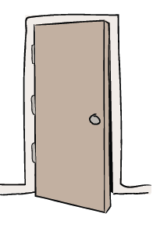 | The Door – Actions for Change  Putting thoughts and ideas into action.  The symbol of the door allows children to have opportunities to respond, to do something, to go through the door and take action.  The door aims to develop and nurture children to have the confidence to truly believe that they can make a difference in the world. | - Opportunities to compete in sport and other activities to build individual and team character and help to embed values.  - Through learning about health and fitness, children make informed decisions about how to become physically active which has a positive impact upon their lifestyles.  - Children draw upon their Christian Values when participating in sporting activities, both in and out of school, playing competitively but always upholding respect.

