Spirituality in our Science Curriculum
At Highfield St Matthew’s, we use the Candle, Windows, Mirrors and Doors approach to support children in their spiritual and moral development. We have looked at our bespoke ‘SHINE Curriculum’ to identify subject specific spirituality opportunities for each curriculum area.
“Spirituality is not something we can see; it is something we feel inside ourselves. It is about awe and wonder, asking questions, inspiration and being aware of something ‘bigger’ outside of ourselves.”

Spiritual Development – Candle, Windows, Mirrors and Doors
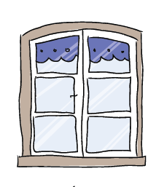 | The Window – Looking Out  Learning about encounters  The image of the window symbolises ‘looking out’ at the awe and wonder of the world. The window also helps us to question things which may worry us or take us by surprise.  The window prompts children to reflect upon what they see around them as they look out upon the world we live in. | - The Science curriculum sparks children’s curiosity and encourages children to recognise the power of rational explanation and develop a sense of excitement about natural phenomena.  - Children can develop a sense of awe and wonder about the world around them by understanding nature, processes and methods of Science.  - Give opportunities to pause and appreciate the beauty of the world around us.  - Explore and understand the correlation between all living things in God’s world and the impact of the elements on the physical world.  - Spirituality in Science is having the ability to feel enormously insignificant (compared to the scale of the physical universe) and enormously significant (that we are genetically unique)  - Awareness that new discoveries are still being made all the time which can redefine scientific understanding.
 | The Mirror – Looking In  Learning from reflections  The mirror symbolises reflecting upon your own actions, thoughts and beliefs to ‘look inside’ and to ask important questions, learning from our own and other’s responses. | - Opportunities to connect with the spiritual experience, that drives us onwards in our search for understanding and deeper meaning, about the big questions relating to the purpose of life.  - Asking questions about how scientific discoveries from around the world have affected our lives; considering a rich heritage of scientific discoveries from other faiths and why scientific beliefs have changed over time.  - Experience great admiration and respect for their own work and the discoveries of different Scientists which could be used to bring hope to others.  - Children are able to pause for reflection in relation to different themes within science, thinking about life in its deepest from.
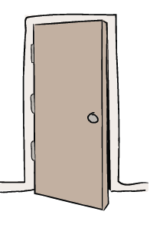 | The Door – Actions for Change  Putting thoughts and ideas into action.  The symbol of the door allows children to have opportunities to respond, to do something, to go through the door and take action.  The door aims to develop and nurture children to have the confidence to truly believe that they can make a difference in the world. | - Children respond to opportunities in the curriculum which action a change for themselves, others, or the environment. E.g. healthy lifestyles, sun safety and protecting habitats.  - Opportunities for children to voice their opinions and beliefs about ‘Life’s Big Questions.’  - Allowing children to use their scientific knowledge and understanding to investigate scientific concepts through exploration of enquiry. E.g. Carrying out experiments, challenging an experiment outcome or proving a theory.

